

Reference Interconnect Offer
Regarding
Mobile Voice Termination

This Reference Offer starts to produce effects as of 1st July 2021 until one subsequent Reference Offer is validly published

TABLE OF CONTENTS

1
TABLE OF CONTENTS 2
1. INTRODUCTION 3
1.1 Scope and limits of the Orange Belgium Reference Interconnect Offer 3
1.2 Evolution of the Orange Belgium Reference Interconnect Offer 3
1.2.1 Regulatory evolutions 3
1.2.2 Technical evolutions 3
1.3 Orange Belgium Glossary 4
Interconnect Link Capacity 7
1.4 Interconnect Agreement 17
1.5 Interconnect Architecture 18
2. MAIN BODY 18
2.1 Essential requirements relating to the Interconnect Services 18
2.2 Terminating Access Services 20
3. TECHNICAL SPECIFICATIONS 20
3.1 Physical Interconnection – Preferred Model 20
3.2 Physical Interconnection – Alternative Model: Mid-Span 22
3.3 Voice Interconnection 23
3.4 SMS Interconnection 26
Interconnection Tests 27
4. PRICING 27
4.1 Terminating Acc Service 28
4.2 Billing and Accounting 28
4.3 Financial guarantee - Long-term financial strength 29

1. INTRODUCTION

Scope and limits of the Orange Belgium Reference Interconnect Offer
This Reference Interconnect Offer deals with Interconnect Services which Orange Belgium offers to a duly authorized Public Network Operator, hereafter called “Operator”, for termination of voice calls to Orange Belgium Mobile Subscribers.

This Reference Interconnect Offer has been issued and developed in accordance with the obligations imposed on Orange Belgium in the BIPT decision of 01 July 2021.

The Interconnect Services included in this Reference Interconnect Offer encompass the following services:

- Terminating Access Services, as described in detail in section 2.2 below;

This Reference Interconnect Offer does not cover calls to numbers which were initially attributed to Orange Belgium but which were ported to other networks. As a general rule, this Reference Interconnect Offer does not consider issues of mobile number portability.

Other interconnect services may be negotiated between Orange Belgium and the Operator and included in the Interconnect Agreement.

As a general principle, Orange Belgium is not responsible for the content of the communications conveyed through its Interconnect Services.

Evolution of the Orange Belgium Reference Interconnect Offer

Regulatory evolutions
The conditions for Interconnection contained in the present offers are applicable for the period from July 1 2021, until a new Reference offer is published.

Technical evolutions
Orange Belgium has started the migration of the TDM network towards a VoIP network infrastructure.

Orange Belgium Glossary
Capitalized terms and expressions used in the present Reference Interconnect Offer shall have the respective meaning as specified in the definition catalogue below.

The definitions included in this Reference Interconnect Offer are proper to this document.

Abnormal usage of Interconnect links  Access Area | Is the usage when in case of outage any Party primary link (physical issue, configuration error…) this Party is using the other Party’s primary link Back-up bandwidth to carry out its originated traffic for non-acceptable duration exceeding the normal time of outage recovery and repair. The non-acceptable duration is set up to 30 consecutive calendar days. The consequence of abnormal duration is that the geographical redundancy of Interconnection between the Parties is no more active and there is a major risk for conduction of Interconnect Services.  Area within the Network of the Party in which Interconnection Services are offered at specified Access Points
Access Point (AP) | Location of the physical interface within one of the Party’s Network to which Interconnect Links can be connected by another Party
Accounting and Billing Document | Document setting out the accounting and billing rules contained in Annex D to this Agreement
Active VLAN  Answer Signal Message | A dedicated VLAN configured on the primary Interconnect link of the Party to carry out Party’s originating traffic.  A message sent in the backward direction indicating that a Call has been answered. In semi-automatic working this message has a supervisory function. In automatic working this message is used in conjunction with charging information in order to  - start metering the charge to the calling customer  - start measurement of call duration for inter-Operators accounting purposes
Back-up VLAN  Belgian National Numbering Scheme | A dedicated VLAN configured on the primary Interconnect link of the other Party to carry out the Party’s responsible traffic in case of failure of this Party primary link.  National numbering scheme for Belgium as administrated by the competent national authority
Billing Data | Data, as defined in the billing and Accounting Document and its related appendices, which is recorded by each Party for each Call via the Interconnect Billing System and which comprises, at a minimum: (i) call type; (ii) called party number; (iii) calling Line Identification if available; (iv) identification of the Access Points of the Parties from which and to which the Call is handed over; (v) the date and the time when an Answer Signal Message is received by the Party providing the Billing Data; (vi) the Chargeable Call Duration; and (vii) the Circuit Group if available. Other data may be considered as Billing Data in accordance with Annex B, which data is necessary to ascertain the charges payable by each Party under this Agreement
Billing period  Billing process  BIPT | Billing Period means a calendar month following the Accounting period  The process of generating invoices and sending bills to collect money owed after a transaction has been completed.  Belgian Institute for postal services and telecommunications
Bringing Into Service (BIS)  Call  Call Type | Date for bringing into service as agreed in accordance with the rules set out in the Planning and Operation document  The establishment of a connection through a Network system and the transmission and the delivery of a communication, from the terminal on which this communication has been generated to the terminal to which this communication is addressed, or to a network platform or to any other facility giving an automatic answer in the cases where the connection cannot be established  A call type is a category of incoming call and is used to select a routing script for a call.
Calling Line identification (CLI) | The identity of the calling line, based on E.164 numbers, validated by the originating network and transmitted to the terminating network by means of signalling.
Calling Line Identification Presentation (CLIP) | A supplementary service offered to a Called Party which provides the Calling Party’s number to the Called Party
Calling Line Identification Restriction  (CLIR) | A supplementary service offered to the Calling Party to restrict the presentation of the Calling Party’s number to the Called Party
Interconnect Link Capacity | A parameter for the communication volume between the Parties which can be expressed as bandwidth or as number of simultaneous calls. It is applicable to an Interconnect link or an interconnect VLAN or an interconnect trunk group for dimensioning
Carrier Price List (CPL )  CDR  Charge | A document summing up the different interconnection services and the applicable prices offered by one party and accepted by the other.  A call detail record is a data record produced by a telephone exchange or other telecommunications equipment that documents the details of a telephone call or other telecommunications transaction (e.g., text message) that passes through that facility or device. The record contains various attributes of the call, such as time, duration, completion status, source number, and destination number. It is the automated equivalent of the paper toll tickets that were written and timed by operators for long-distance calls in a telephone switch telephone exchange.  to fix or ask as fee or payment
Chargeable Call Duration | The time interval, rounded up to the nearest second, that elapses between:  • the moment at which the answer signal (in the backward direction) is detected at the concerned Access Point  • the moment at which the clear forward or clear backward condition is detected at the concerned Access Point
Default Interest Rate | The monthly interest rate published in “Belgisch Staatsblad”.
Defaulting Party | Party failing to respect its obligations under this Agreement
Demarcation Point | The physical point (interface or patch panel) where one Parties’ responsibility for the Service ends and the other Parties obligations start. It identifies and establishes the dividing line between the appropriate areas of responsibilities of the Parties.
Direct Interconnection | The physical linking of two networks for the mutual exchange of traffic
Dispute | Any disagreement between the Parties under or in relation to this Agreement or the Interconnection between the Parties and as referred to this Interconnection Agreement
Due Date | The date of the invoice plus thirty (30) Calendar Days as defined in the Billing and Accounting Document (art 5)
Effective Date  Emergency Call | It’s the date upon which something is considered to take effect, which may be a past, present or future date.  Call to one of the numbers, specified in the Royal Decree 02/02/2007
Essential Requirements | Requirements referred to in Article 7 of this Agreement
FLO  FOLO | Foreign Licensed Operator  Fixed Other Licensed Operator
Freephone Service | Service which allows the calling party to make free of charge Calls, which are paid for by the Service Provider
Geographical Number | Number of which PQ corresponds to a country geographical zone
Interconnect Agreement | The agreement concluded between Orange Belgium and OPERATORS under which the Parties provide each other a number of Interconnect Services. This agreement includes a main body and the Annexes
Interconnect Billing System | The system used to charge a Party for the amounts due for the provision of Interconnect Services by the other Party under this Interconnect Agreement.
Interconnect(ion) | The physical and logical linking of telecommunications networks and the providing of services in order to allow users connected to one network to communicate with users connected to another network, or to allow the users connected to a network to access services provided by another organisation than the one operating the network to which those users are connected
Interconnect Link (VOIP) | IP link between Orange Belgium Access Point and a OPERATORSAccess Point in order to enable the provision of Interconnect Services.
Interconnect Link Service | An Interconnect Service necessary for the establishment of an Interconnect Link
Orange Belgium Interconnect Link | Interconnect Link that is provided in its entirety by Orange Belgium to the AP of OPERATORS.
OPERATORS Interconnect Link | Interconnect Link that is provided in its entirety by OPERATORS to the AP of Orange Belgium.
Interconnect Services | Services provided by the Parties under an Interconnection Agreement with a view to enable interconnection between the Party’s respective Networks.
International Incoming traffic | Traffic originated outside Belgium and handed over by one Party for the termination by the other Party on its network.
International Outgoing traffic | Traffic originated in Belgium that is handed over by one Party for conveyance and termination outside of Belgium by the other Party
Invoice Date | The date mentioned on the invoice
Link | Set of telecommunication facilities necessary to establish one or more transmission paths between two locations
Mobile Number Portability Service MNP) | The service that allows a cell phone or smartphone customer to change the telecom carrier and to keep the same phone number
MOU | Memorandum of Understanding
MOLO | Mobile Other Licensed Operator
Negotiation Document | Document issued by the BIPT to a Party confirming that the Party, under the conditions set out in the document concerned is entitled to negotiate an Interconnection
Network (Telecommunications Networks) | The transmission systems and, where applicable, the switching equipment and other resources which permit the conveyance of signals between defined termination points by wire, by radio waves, by optical or by other electromagnetic means
Network Operation Centre | Center Responsible for the operation of the Network of the Party concerned
Normal usage of Interconnect link  Notice  OLO | Is the usage when the primary link of the Party is used to carry out this Party originated traffic and provided a reserved bandwidth to the other Party in back-up mode the to carry out the originated traffic of the other Party in case of outage.  Notification or warning of something, especially to allow preparations to be made  Other (than Orange Belgium) Licensed Operator. Moral or physical person being granted by the competent Belgian authorities an adequate individual authorisation to install and operate a Public Telecommunications Network and/or offer Public Voice Telephony Services in the whole or a part of the Belgian territory
Party | Respectively, Orange Belgium and OPERATORS for the purposes of the Interconnect Agreement
Point of interconnection (POI)  Point of Demarcation (POD) | The physical location where the Parties interconnect their respective networks thereby establishing the technical interface and points for operational division of responsibility.  The physical point (transmission layer) where Orange Belgium’s Network and the Operator’s Network are connected. The Point of Demarcation is the boundary between the Orange Belgium and the Operator domains of operations responsibility
POP | Point of Presence. Physical interface within an Operator’s System which can be interconnected to an Orange Belgium Access Point in order to allow for the provision of Interconnection Services offered at that Access Point/POP
Premium Rate Numbers | Telephone numbers (090X) with a higher price charge than normal calls used for added value services
Primary link  Public Telecommunication Services | IP link to carry operator originated voice traffic to the other party.  Services whose provision consists wholly or partly in the transmission and routing of signals on telecommunications networks and which are available to the public
Public Telecommunications Network | A telecommunications network used inter alia for the provision of telecommunications services available to the public
Service Plan (SP) | The description of an Interconnect Service, offered by a party to the other party
SMS-C  SPOC | A Short Message Service Center is a network element in the mobile telephone network. Its purpose is to store, forward, convert and deliver Short Message Service (SMS) messages.  The Single Point of Contact between Orange Belgium and OPERATORS as defined by article 7.1 of the Agreement
Successful Call | A call during which an answer message (in the backward direction) has been received in accordance with the applicable international recommendations.
Tariff Period  Telecommunications Network | It means the period for which tariff is to be determined on the basis of norms specified in the CPL.  The transmission systems and, where applicable, the switching equipment and other resources which permit the conveyance of signals between defined termination points by wire, radio waves, by optical or any other electromagnetic means.
Terminating Party | Party to which a call is handed over to be terminated
Traffic (Flow) | A set of VOIP Calls characterized by the fact that all the VOIP Calls which constitute this flow have the same direction (towards or from an Access Point)
Orange Belgium Responsible Traffic (ORT) | Orange originated Traffic which is under responsibility of Orange for Forecasting & ordering as detailed in Annex G Planning and Implementation and relevant Service Plans
OPERATORS Responsible Traffic (VRT) | OPERATORS originated Traffic which is under responsibility of OPERATORS for Forecasting & ordering as detailed in Annex G Planning and Implementation and relevant Service Plans
Transit Interconnect Traffic | Service on the basis of which one of the Parties ensures that the traffic of the other Party can be conveyed to a third party with whom the first Party has adequate contractual relations.
Validation Data  Voice Telephony Service  VOIP Call | Means checking the accuracy and quality of source data before using, importing or otherwise processing data.  Service offered to the public for commercial exploitation of direct transport of voice in real time via a public network and giving the possibility to each user to use the equipment connected to a network termination point in order to communicate with another equipment user connected to another network termination point  VoIP is short for Voice over Internet Protocol. Voice over Internet Protocol is a category of hardware and software that enables people to use the Internet as the transmission medium for telephone calls by sending voice data in packets using IP rather than by traditional circuit transmissions of the PSTN.

The definitions thus specified shall apply equally to the singular and the plural forms of the terms defined. Whenever the context may so require, any pronoun shall include the corresponding masculine, feminine and neuter forms.

Interconnect Agreement
The Interconnect Agreement is the agreement concluded between Orange Belgium and the Operator setting out in particular, the technical, operational, billing, planning and financial conditions for the Interconnection Services provided by Orange Belgium to the Operator pursuant to this Reference Interconnect Offer and for the Interconnection between both Networks.

As the case may be, the Interconnect Agreement can cover additional interconnect services provided by the Operator or Orange Belgium respectively to each other.

The Interconnect Agreement will include in any event the elements contained in the Main Body of this Reference Interconnect Offer. Except if otherwise agreed by the Parties, the Interconnect Agreement shall be adapted when the Orange Belgium Reference Offer is modified. This adaptation shall be in accordance with this Orange Belgium Reference Offer’s modification.

The conclusion of an Interconnect Agreement is a prerequisite for the Bringing into Service of the Interconnection between the Parties and of the Interconnect Services.

Negotiations in view of concluding an Interconnect Agreement can only start after:

- the Operator has provided Orange Belgium with the necessary documents demonstrating that the Operator has obtained the necessary authorizations from the BIPT to benefit from the Interconnect Services offered under the present Reference Interconnect Offer.
- the Operator has signed a Non-Disclosure Undertaking vis-à-vis Orange Belgium.

At the start of the negotiations towards an Interconnection Agreement, but after submission of the above mentioned relevant documents and after signature of a Non-Disclosure Undertaking by the Operator, Orange Belgium and the Operator will sign a Letter of Intent (“LOI”) in view of the conclusion of an Interconnection Agreement. After the signature of the LOI, the testing can take place as described in the Planning and Operations document contained in Annex 2 to this Reference Interconnect Offer.

Interconnect Architecture
Interconnection is realized by the linking of two Access Points each of them located in the Networks to be interconnected. The linking of Access Points is implemented by means of an Interconnect Link. The demarcation point is located on the Interconnect Link and is the physical point where both networks are interconnected. It represents as such the boundary between the responsibility of Orange Belgium and the interconnected Operator.

Orange Belgium has started the migration of the TDM network towards a VoIP network infrastructure.

Interconnection to the Orange Belgium Network will only be possible at the site where an Access Point is located.

MAIN BODY

Essential requirements relating to the Interconnect Services
The present chapter describes the essential obligations applicable to the Operator to whom Orange Belgium provides Interconnect Services under the Reference Interconnect Offer and the Interconnect Agreement:

- Volume obligation:

The Operator must achieve a minimum monthly volume of 1.500.000 minutes of Orange Belgium Terminated Calls, of which at least 1.000.000 voice call minutes per month are national originated calls.

- Direct Interconnection:

The Operator will send all voice traffic to Orange Belgium Subscribers (Orange Belgium terminated voice calls), immediately over the direct Interconnect Link between the Parties, without transiting the traffic through a national or international third party.

The Operator cannot use, directly or indirectly, GSM Gateways to terminate traffic to Orange Belgium Mobile Subscribers.

- CLI:
The Operator must respect the following minimum principles with respect to the use of the CLI in addition to any other regulatory obligations that might exist :

- The CLI must always represent the correct number associated with the network termination point of the public network at which the call was originated. The said number is a number which has been allocated by the competent Authority. All operators have to comply, to the extent technically possible, with the relevant ITU recommendations and the European Guidelines for Calling Line Identification as issued by the European Telecom Platform (22 January 1999).

- The Operator will always deliver the CLI for all the Orange Belgium Terminated Calls, which are either originated on the Operator’s network or for which the CLI was present when arriving on the Operator’s network (CLI transparency).
If the Operator fails to adequately respect one of the essential obligations set out above under (1), (2), or (3), Orange Belgium will have the right to suspend the provision of Interconnect Services after having communicated the infringement to the Operator by prior written notice of minimum one (1) month. If such suspension is maintained for more than three (3) months, and no reasonable solution has been agreed on between the Parties during that period, the Operator’s default will be considered as a serious default and Orange Belgium will have the right to unilaterally and immediately terminate the provision of the Interconnection Services and the Interconnect Agreement.

In addition, the Operator recognizes that the Interconnection and the Interconnection Services can by no means constitute an infringement of the terms of Orange Belgium’s mobile license, in particular the essential requirements as defined in Article 4 § 5 (1° - 4°) of the Royal Decree of 7 March 1995 regarding the construction and the exploitation of GSM-mobile telephony networks as well as the Article 4 § 4 of the Royal Decree of 24 October 1997 regarding the construction and the exploitation of DCS-1800 mobile telephony networks, 2nd subsection (1° - 4°), respectively Article 6 § 1 (1° - 4°) of the Royal Decree of 22 June 1998 regarding the conditions as to the construction and the exploitation of public telecommunication networks. Should this be the case, Orange Belgium will be entitled to take all necessary measures, in discussion with the Operator, to make an end to this infringement situation.

Terminating Access Services
The Orange Belgium Terminating Access Service consists of the conveyance by Orange Belgium of originated voice Calls sent by the Operator to an Orange Belgium Mobile Subscriber – which is not a Mobile Station Roaming Number (MSRN) – as from the Access Point.

An Orange Belgium Mobile Subscriber is characterized by
- a mobile number that belongs to the range of numbers which has been attributed by the BIPT to Orange Belgium and which has not been ported out to another operator, or
- a mobile number which does not belong to the number ranges attributed by the BIPT to Orange Belgium, but which has been ported to Orange Belgium.

A call towards a mobile number which belongs to the range attributed by the BIPT to Orange Belgium, but which is ported out to another operator (and which has not been “ported back” to Orange Belgium) does not fall within the scope of this Reference Interconnect Offer.

The prices applicable to the ‘Orange Belgium Basic Terminating Service’ are indicated in section 4.1 below.

For the avoidance of doubt, the Operator is responsible for the setting of its own retail prices and for the invoicing of its customers for the calls to Orange Belgium Mobile Subscribers originated on the Operator’s Network.

TECHNICAL SPECIFICATIONS

Physical Interconnection – Preferred Model
Orange proposes the following architecture model to setup an IP interconnection for Voice (SIP) and SMS (SIGTRAN):

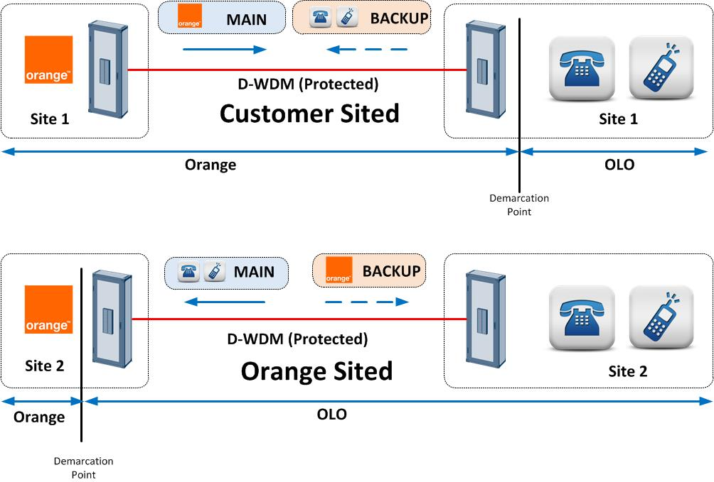
Figure 1: Mutualized IP Interconnection

In this model, each party will setup a physical link between its network and the other operator network. This architecture offers the following benefits:
- Geographical Redundancy
- No recurrent fees or additional cost to charge to the other operator as everyone is responsible for its own path.
- Resources optimization by sharing bandwidth between both operators
- Balanced Model

Physical Interconnection – Alternative Model: Mid-Span
If it not possible to meet at other operator location, an alternative solution will consist to meet in two independent datacentres hosted and managed by a third-party.

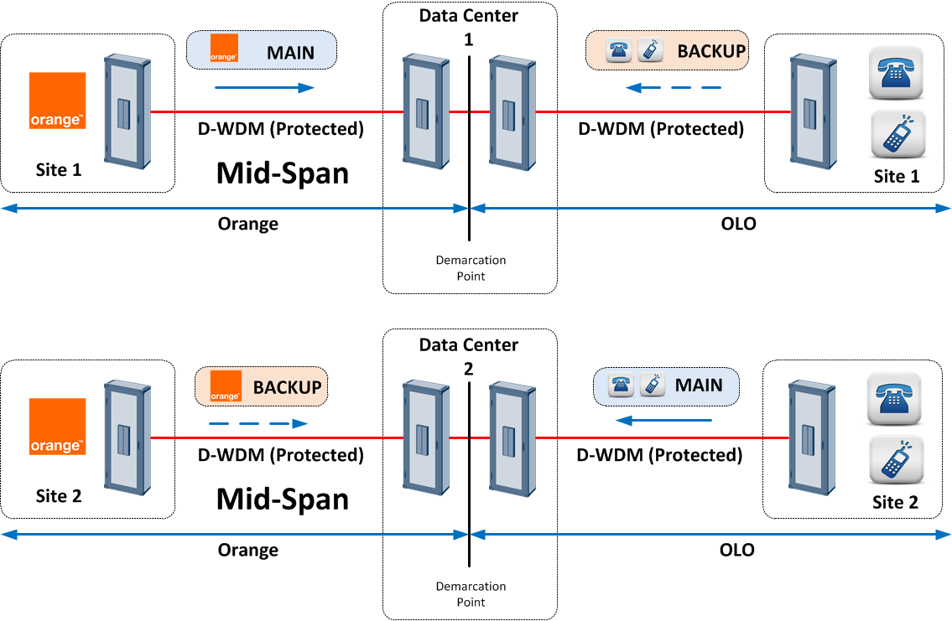

Figure 2: Mid-Span IP Interconnection

In this model, each party will setup two physical links between its network and the datacenter where the junction with the other operator will be realized.

This architecture offers the same benefits as the previous model. However, two third parties will be involved, generating cost increases and potential complexity in troubleshooting.

Voice Interconnection
To carry voice between both operators, the interconnection is based on Interworking between Session Initiation Protocol (SIP) and Bearer Independent Call Control protocol.

The minimum bandwidth that will be installed on each path is a 1 Gbps.

On those IP link, a dedicated VLAN will be created to carry SIP and RTP between Orange and the other operator.

For voice CODECs, the default ones will be the following one:
- Voice through G.711 A law with packetization time of 20ms (recommended)
- Fax through T.38 or Pass through G.711

Static routing will be defined between Orange Belgium and the other operator. With static routing, each operator will implement a corresponding entry on its router to ensure that the other operator network can be accessed via the direct interconnection.

Orange Belgium will interface two I-SBC installed on two independent core sites, for geographical redundancy purpose. Each I-SBC will be interfaced to other operator I-SBC on two other core sites that will be connected through the DWDM.

The following picture shows the voice interconnection architecture and call flows that will be built between Orange Belgium and the other operator:

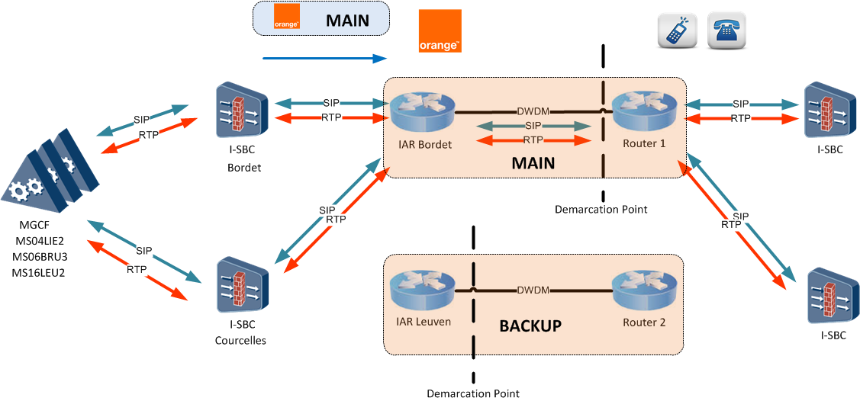

Figure 3: Calls from Orange to OLO

Calls from Orange to OLO will be generated by both I-SBC and both OLO I-SBC will be addressed in the same way. However, all calls will be routed towards the first physical link that ends up at OLO premises. The second link will be used in case of main link becomes unavailable for any reason.

For calls from OLO to Orange, the same path can be used in a reverse way. Or the following call flow can be used instead:

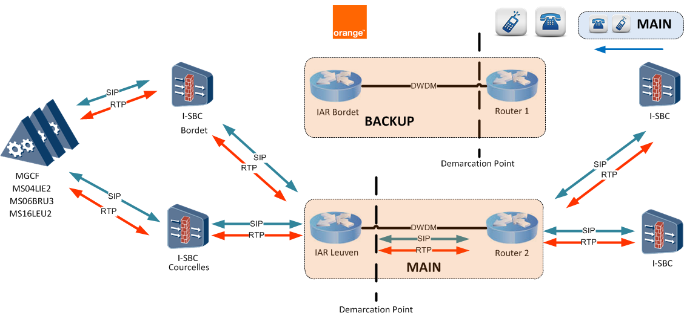

Figure 4: Calls from OLO to Orange

In this architecture, all SIP and RTP flows are routed towards the other physical link that acts as the main one for OLO perspective while the other one is defined as the backup one.
The way to route IP flows will be agreed between both parties during technical discussions.

SMS Interconnection
For SMS interworking, the physical link used for voice will be used as well. Only a different VLAN will be created to carry SIGTRAN between Orange and the other operator.
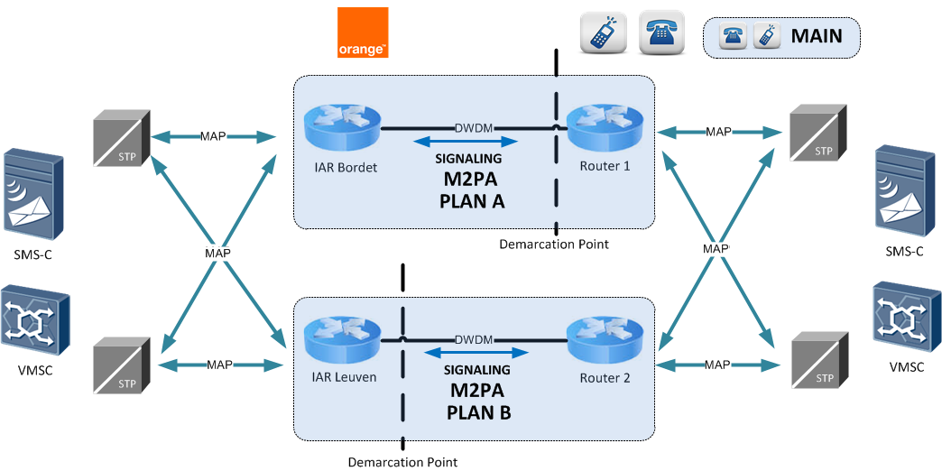

Figure 5: SMS Interworking

Direct SMS Interworking will be realized through MAP Interco over SIGTRAN M2PA links.

SCCP addressing will be in international format and both operators will perform SMS Home Routing.

Interconnection Tests
The initial interconnection tests consist of:

- Conformance testing:
The goal is to test the interworking between the Orange Belgium switches (Huawei MSOFTX3000), the Orange Belgium I-SBC (Oracle ACME Packet 6300) and the other operator equipment’s.

- Compatibility testing:
The goal is to verify the correct implementation of call related data in both switches (numbering, routing, etc.) to ensure correct network integration.

- Billing testing:
The billing data processed at both sides of the interconnection are compared for the different call cases.

- Quality testing:
The quality of the interconnection is compared with the other Orange Belgium interconnection.

The set of compatibility tests needs to be repeated whenever a major upgrade takes place, or, when a new interconnection is installed. Each service offered on the interconnection, requires an appropriate compatibility testing.

The test descriptions and the tests certificates are available in another document: the interconnection test book (on demand).

PRICING

All prices indicated below are expressed in euro or eurocent and are exclusive of any taxes.

Terminating Acc Service

The MTR rate valid as from January 1st, 2022 is the following:

Eurocent/min | Duration
Group 1* | 0.55
Group 2* | 1.5
Group 3* | 10
Group 4* | 15
Group 5* | 25

Group 1: Belgium + EU + EFTA (including “+1” country code, China and India)
Group 2, 3, 4 & 5 see annex at the end of the Offer

In case the conditions defined in Article 1 paragraph 4 of the Commission Delegated Regulation (EU) 2021/654 of 18 December 2020 are met, the rates as defined in the Articles 4 and 5 of the same regulation shall apply for calls originated from third country-numbers and terminated to Union-numbers.

Billing and Accounting
The Interconnect Services will be charged following the terms and conditions as specified in the billing and accounting manual included in the Interconnect Agreement. Below follows a summary of some of the main conditions:

Charging Principles
Orange Belgium applies the following rounding principles:
- The number of Calls is not rounded
- The Chargeable Call Duration is, per call, rounded up to the nearest second, e.g. 5 min 20.5 sec is rounded to 5 min 21 sec, 5 min 20.4 is rounded to 5 min 21.
- Euros are rounded to the nearest euro cent. For example: 5.2341= 5.23 EUR, 5.2361=5.24 EUR
- For the purpose of billing the rounding is only applied on the final total payable amount of the invoice.

The use of decimals is set as follows:
- In the rates up to 6 decimals in Euro.
- The revenues and the totals use 2 decimals in Euro.

Invoices
Orange Belgium shall endeavor to issue invoices within 30 calendar days after the end of the applicable Billing Period, unless if Orange Belgium has notified the Operator of a delay in the invoicing.

Payment & disputes
All charges due by the Operator to Orange Belgium under the Interconnect Agreement shall be paid within 30 calendar days after issuance of the invoice (the “Due Date”).

The Interconnect Agreement lays down the detailed relevant provisions regarding invoice disputes. The basic principle is that no dispute will exist where the divergence of views of the Parties is the result of normal and acceptable discrepancies (without prejudice to the above charging & rounding principles), between measured billing data of the Orange Belgium and the validation data measured by the Operator. Therefore, the dispute resolution procedure provided will only be triggered:
- if the dispute is related to any discrepancy that exceeds 2% on any total invoice if the dispute is related to an Interconnect Usage Report; or
- if the total disputed amount is related to any discrepancy that exceeds 2% on any total invoice , if the dispute is related to an Interconnect General Report.

As a general rule, if the disputed amount is less than 3% of the total amount of the relevant invoice (excluding VAT), then the total amount of the invoice is payable on the Due Date.

If payment is not received by Orange Belgium on or before the Due Date, Orange Belgium will be entitled to an interest calculated on the basis of the legal interest rate on the unpaid balance for late payment interests, administrative and recovery costs. This interest shall accrue from the Due Date until the date of payment in full of the amount to be paid. Such interest shall accrue day by day and shall not be compounded.

Financial guarantee - Long-term financial strength
The Operator must bring proof of its respective long-term financial strength. This proof of financial stability must show that a long-term relation with the Operator does not involve any financial risk. More particularly, the Operator must demonstrate “sufficient creditworthiness”, as evidenced by either of the following alternatives:

- The Operator has obtained “Ba2” rating or above for its debt (Moody's);
- The Operator has obtained a rating similar to Moody’s “Ba2” rating, provided that (i) such rating is generally accepted by the market as giving similar reliability as Moody’s, and (ii) such rating is generally reviewed and updated on a regular basis.

In the event that, at some point in time in the course of the Interconnection Agreement, the Operator would not dispose of or loose the above described creditworthiness (either through the loss of the “Ba2” rating or similar, or upon the occurrence of any default or delay of payment), the Operator will have to provide Orange Belgium with any of the other guarantees described below within five (5) Working Days from the request of Orange Belgium.

- The Operator obtains and submits an unconditional and irrevocable parent corporation guarantee for the debt incurred by the Operator for the Interconnect Services ordered under the Interconnection Agreement provided that such parent corporation guarantee is issued by a company that has sufficient creditworthiness as defined above. In the event that the parent company would lose the above described creditworthiness at some point in time in the course of the Interconnection Agreement either through the loss of the “Ba2” rating or similar, or upon the occurrence of any default or delay of payment), the Operator will provide Orange Belgium with a prepayment or with another financial guarantee as described in the present section within five (5) Working Days from the request of Orange Belgium.

- The Operator has constituted a Deposit on an escrow account with a reputable bank or financial institution established in the EU. The amount of that deposit will be equal to an estimate of three months of invoices due by the Operator for the Interconnect Services ordered under the Interconnect Agreement. Based on the actual evolution of the amounts due for the services, the Operator and Orange Belgium will have the right to require an adaptation of the amount of the deposit every three months. Upon the request for adaptation of the amount of deposit, necessary steps will be taken to ensure adaptation within 20 working days. In case of default by the Operator to pay sums due under the Interconnect Agreement, the sums deposited on the escrow account will accrue to Orange Belgium. The interests accrued on the escrow account will be payable to the Operator. In the event the sums deposited are accrued to Orange Belgium, the Operator will provide Orange Belgium with a prepayment or with another financial guarantee defined in the present section within twenty (20) Working Days from the request of Belgacom.

- The Operator has provided Orange Belgium with an irrevocable and unconditional bank guarantee on first demand issued by a reputable bank or financial institution established in the EU. That bank guarantee will be issued for a minimum period of three years and for an amount equal to an estimate of three months of amounts due by the Operator for the Interconnect Services ordered in accordance with the Interconnect Agreement. Based on the evolution of the amounts due for the Interconnect Services, the Operator and Orange Belgium will have the right to require an adaptation of the amount of the bank guarantee every three (3) months. Upon the request for adaptation of the amount of the bank guarantee, necessary steps will be taken to ensure adaptation within twenty (20) working days. Upon expiration of the bank guarantee or after Orange Belgium has called upon the bank guarantee, the Operator shall provide Orange Belgium with a pre-payment or with another financial guarantee as defined in this section within twenty (20) Working Days from the request of Belgacom.

- The Operator has provided Orange Belgium with a monthly prepayment based on the average of the monthly amount due by the Operator. The amount of prepayment shall be based on the average of the invoices issued by Orange Belgium during three months for the Interconnect Services ordered in accordance with the Interconnect Agreement. The amount of prepayment shall be reviewed every three (3) months. The terms and conditions applicable to prepayment are described in more detail in the Interconnect Agreement.

Without prejudice to any other legal remedies e.g. in accordance with the Interconnection Agreement, in the event the Operator fails to pay on due time any amount due under the above prepayment conditions, Orange Belgium shall be entitled to execute the following alternatives until full payment is made :
  - suspension of the Interconnect Services in accordance with the Communication of the BIPT of 11 June 2003
  - refusal in writing to provide any new IC Link or any new Interconnect Services

