Orange VoIP
Interconnect Offer

Technical specifications

Table of content
1. Technical Specifications 3
1.1. Physical Interconnection – Preferred Model 3
1.2. Physical Interconnection – Alternative Model: Mid-Span 4
1.3. Voice Interconnection 5
1.4. SMS Interconnection 7
2. Interconnection Tests 8

Technical Specifications

Physical Interconnection – Preferred Model
Orange proposes the following architecture model to setup an IP interconnection for Voice (SIP) and SMS (SIGTRAN):

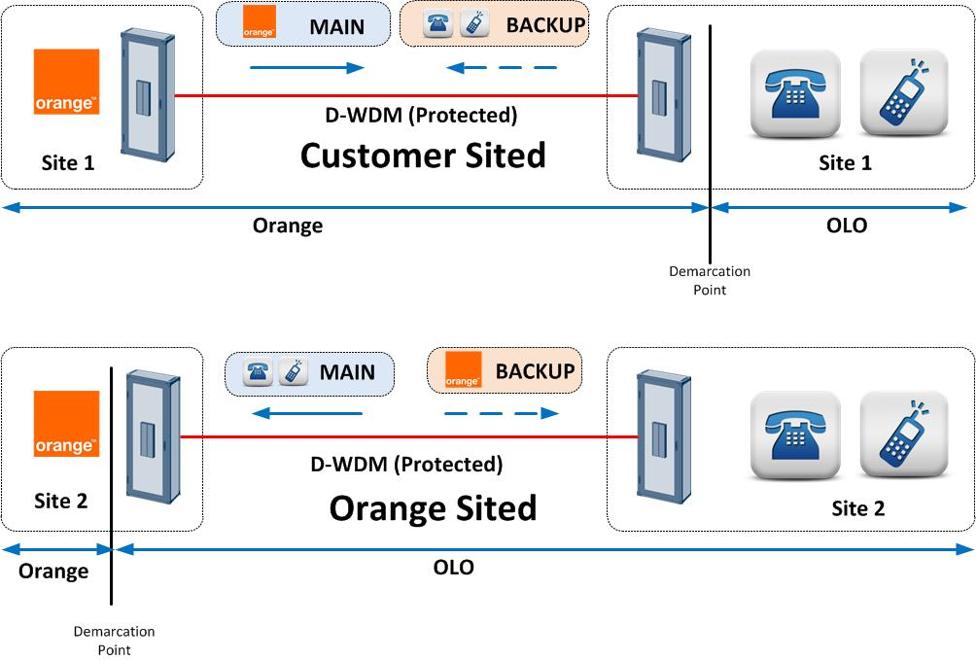
Figure 1: Mutualized IP Interconnection

In this model, each party will setup a physical link between its network and the other operator network. This architecture offers the following benefits:
- Geographical Redundancy
- No recurrent fees or additional cost to charge to the other operator as everyone is responsible for its own path.
- Resources optimization by sharing bandwidth between both operators
- Balanced Model

Physical Interconnection – Alternative Model: Mid-Span
If it not possible to meet at other operator location, an alternative solution will consist to meet in two independent datacentres hosted and managed by a third-party.

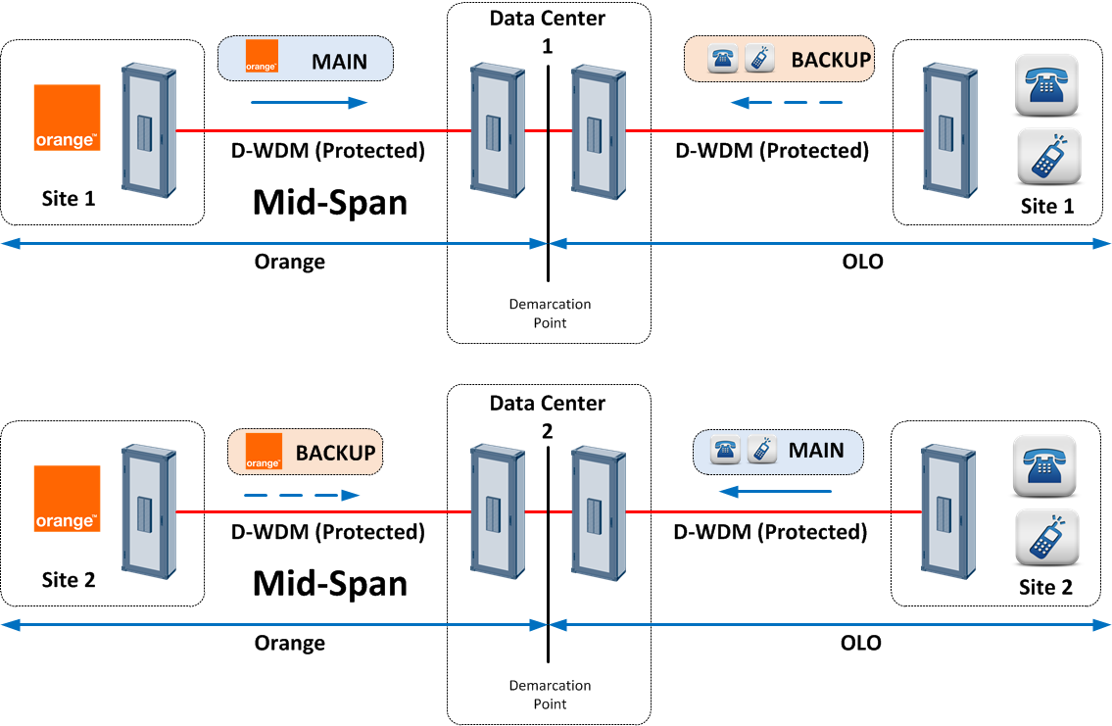

Figure 2: Mid-Span IP Interconnection

In this model, each party will setup two physical links between its network and the datacenter where the junction with the other operator will be realized.

This architecture offers the same benefits as the previous model. However two third parties will be involved, generating cost increases and potential complexity in troubleshooting.

Voice Interconnection
To carry voice between both operators, the interconnection is based on Interworking between Session Initiation Protocol (SIP) and Bearer Independent Call Control protocol.

The minimum bandwidth that will be installed on each path is a 1 Gbps.

On those IP link, a dedicated VLAN will be created to carry SIP and RTP between Orange and the other operator.

For voice CODECs, the default ones will be the following one:
- Voice through G.711 A law with packetization time of 20ms (recommended)
- Fax through T.38 or Pass through G.711

Static routing will be defined between Orange Belgium and the other operator. With static routing, each operator will implement a corresponding entry on its router to ensure that the other operator network can be accessed via the direct interconnection.

Orange Belgium will interface two I-SBC installed on two independent core sites, for geographical redundancy purpose. Each I-SBC will be interfaced to other operator I-SBC on two other core sites that will be connected through the DWDM.

The following picture shows the voice interconnection architecture and call flows that will be built between Orange Belgium and the other operator:

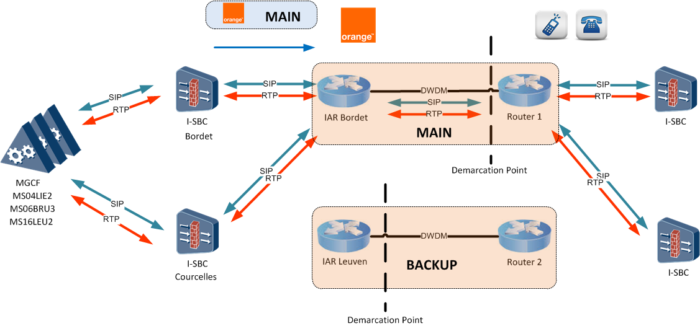

Figure 3: Calls from Orange to OLO

Calls from Orange to OLO will be generated by both I-SBC and both OLO I-SBC will be addressed in the same way. However all calls will be routed towards the first physical link that ends up at OLO premises. The second link will be used in case of main link becomes unavailable for any reason.
For calls from OLO to Orange, the same path can be used in a reverse way. Or the following call flow can be used instead:

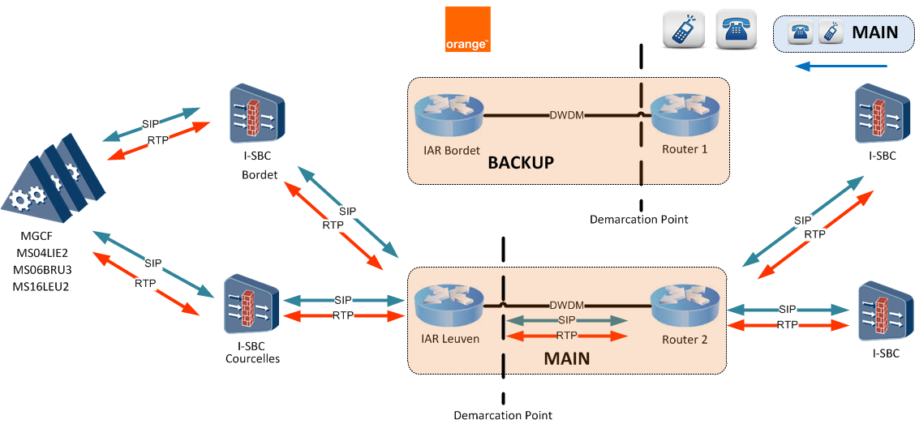

Figure 4: Calls from OLO to Orange

In this architecture, all SIP and RTP flows are routed towards the other physical link that acts as the main one for OLO perspective while the other one is defined as the backup one.
The way to route IP flows will be agreed between both parties during technical discussions.

SMS Interconnection
For SMS interworking, the physical link used for voice will be used as well. Only a different VLAN will be created to carry SIGTRAN between Orange and the other operator.
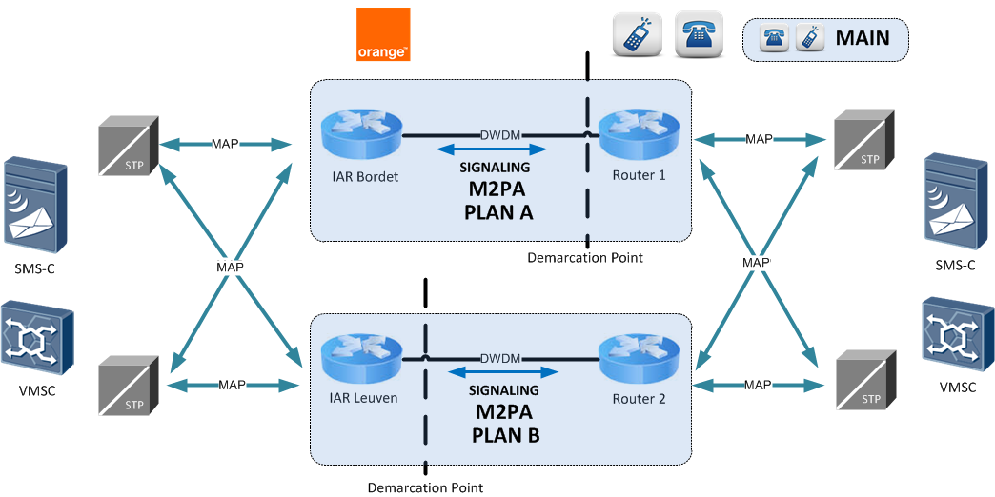

Figure 5: SMS Interworking

Direct SMS Interworking will be realized through MAP interco over SIGTRAN M2PA links.

SCCP addressing will be in international format and both operators will perform SMS Home Routing.

Interconnection Tests
The initial interconnection tests consist of:

- Conformance testing:
The goal is to test the interworking between the Orange Belgium switches (Huawei MSOFTX3000), the Orange Belgium I-SBC (Oracle ACME Packet 6300) and the other operator equipment’s.

- Compatibility testing:
The goal is to verify the correct implementation of call related data in both switches (numbering, routing, etc.) to ensure correct network integration.

- Billing testing:
The billing data processed at both sides of the interconnection are compared for the different call cases.

- Quality testing:
The quality of the interconnection is compared with the other Orange Belgium interconnection.

The set of compatibility tests needs to be repeated whenever a major upgrade takes place, or, when a new interconnection is installed. Each service offered on the interconnection, requires an appropriate compatibility testing.

The test descriptions and the tests certificates are available in another document: the interconnection test book (on demand).

- END OF DOCUMENT -

